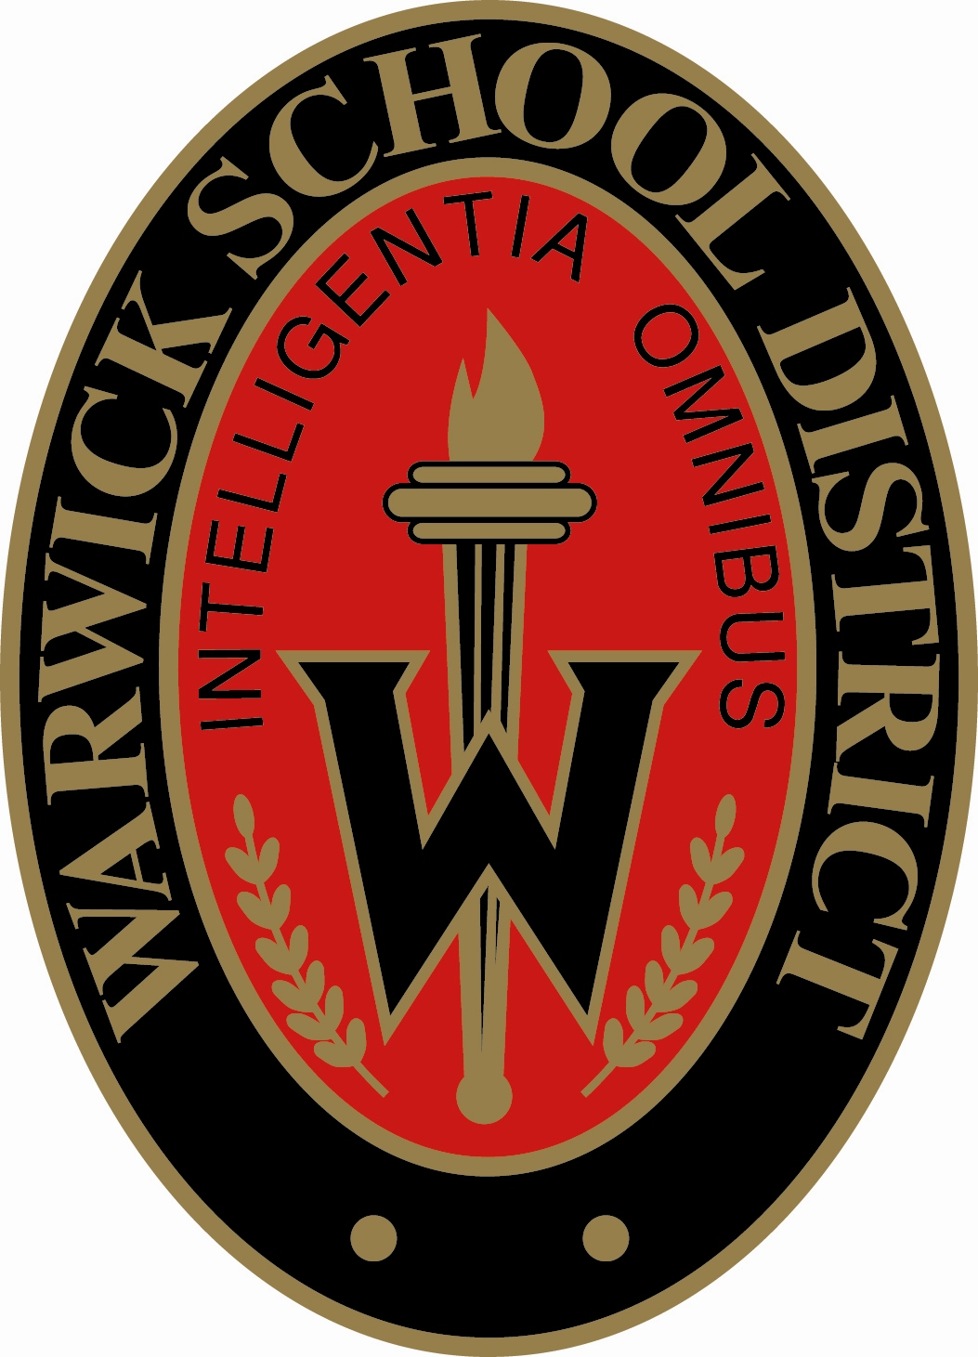
301 West Orange Street
Lititz, PA, 17543
Telephone: 717-626-3700
Fax: 717-626-6199
Warwick High School

Mrs. Kristina Szobocsan High School Principal
Mr. Sydnor Harrison III Assistant Principal
Mr. Scott Kyper Acting Assistant Principal
TBD Assistant Principal

August 10th, 2016

Hello CTC students and families,

I hope you have had an enjoyable summer and are looking forward to the upcoming school year. The Career and Technology Center (CTC) runs on a calendar different from Warwick so I wanted to ensure we communicated the differences to you.

The CTC will open their doors for the 2016-2017 school year on August 29, 2016. ALL students are encouraged to attend classes as of this date. Transportation from August 29th through September 6th is available from the Warwick High School front bus loop and back to the Warwick High School front bus loop. Transportation from home to Warwick and Warwick to home will not be provided until September 7th when Warwick School District begins their school year.

Full Day Willow Street CTC (Graybill)- Bus #44
- Depart at 7:35 a.m.
- Return at 2:30 p.m. (Bus #1 for return trip)

Full Day Mount Joy CTC (Graybill)– Bus #44
- Depart at 7:35 a.m.
- Return at 2:40 p.m.

Full Day Brownstown CTC (Groff) – Bus #42
- Depart at 7:40 a.m.
- Return at 2:45 p.m.

Half-day Brownstown CTC (Groff)- Bus #4
- Depart at 7:40 a.m.
- Return at 10:40 a.m.

More Bus Information
Full-day CTC
- When Warwick does NOT have school and CTC does, Warwick will provide transportation. Transportation will be available from the Warwick High School front bus loop and back to the Warwick High School front bus loop.
- When CTC does NOT have school and Warwick does, students are not required to attend.
Half-day CTC
- When Warwick does NOT have school and CTC does, Warwick will provide transportation.
- Transportation will be available from the Warwick High School front bus loop only in the morning. Students MUST arrange their own transportation back to Warwick High School.
- When CTC does NOT have school and Warwick does, students have the option of coming in at 10:40 with their own transportation or coming in on their regular bus and spending their AM CTC time in study hall in room A108.
Two-hour Delays
- Full-day CTC students will leave 2 hours later than they usually do.
- Half-day CTC students will NOT go to CTC; instead they will report to homeroom and study hall in room A108.

Announcements & Communication
Please check the Warwick High School webpage under High School Daily Announcements link, the Warwick High School lobby window (upcoming dates) and the High School Newsletters for the most up to date information. I encourage CTC students to continually check announcements and communicate with the front office and guidance office when questions arise.

Warwick High School First Day of School
All CTC students (both full day and half day) will need to report to Warwick High School on September 7th for extended homeroom, school assembly and class meetings. When the morning bell rings for homeroom, CTC students should report to the cafeteria.

Transportation to Full Day CTC will be provided for ALL full-day CTC students after these morning activities at approximately 9:45 a.m. Half-day CTC students will remain at Warwick for the entire day.

Half Day Students First Day of School Schedule
Doors Open- 7:50 a.m.
Warning Bell- 7:58 a.m.
Extended Homeroom/Assembly/Class Meetings 8:00-10:07- Begin in Cafeteria
Period 1- 10:12- 10:41- Study Hall in A108
Period 2- 10:46- 11:15- Study Hall in A108
Period 4- 11:20-12:45
Lunch A 11:15-11:45
Class 11:50-12:45

Class 11:20-11:45
Lunch B 11:45- 12:15
Class 12:20- 12:45

Class 11:30- 12:15
Lunch C 12:15- 12:45
Period 3- 12:51- 1:19- Study Hall in A108
Period 5- 1:24- 1:53
Period 6- 1:58- 2:27
Period 7- 2:32- 3:01

Upcoming Dates
9/20- Back-to-School Night – 6:30 p.m.

9/30- Homecoming Tailgate & Football Game 10/1- Homecoming Dance

10/14- Senior Pictures (yearbook photo must be taken by school photographer), Senior
Ads (purchased through Jostens), Senior Survey, Senior Baby Pictures completed

10/24- Assembly for seniors to be measured for caps and gowns and to order
stationery for graduation at 9:00 a.m. Any student not able to attend
should follow up with the High School Main Office.

November- Senior Announcements and Cap & Gown forms with payment are due.

Contact Information
Warwick High School Office- 626-3700
Warwick Counseling Office- 626-3700 ext. 3745
Brownstown Career and Technology – 859-5100
Mt. Joy Career and Technology – 653-3000
Willow Street Career and Technology – 464-7050

Sincerely,

Mrs. Kristy Szobocsan
Principal

