John R. Bonfield Elementary School Pick-Up/Drop-Off Zones

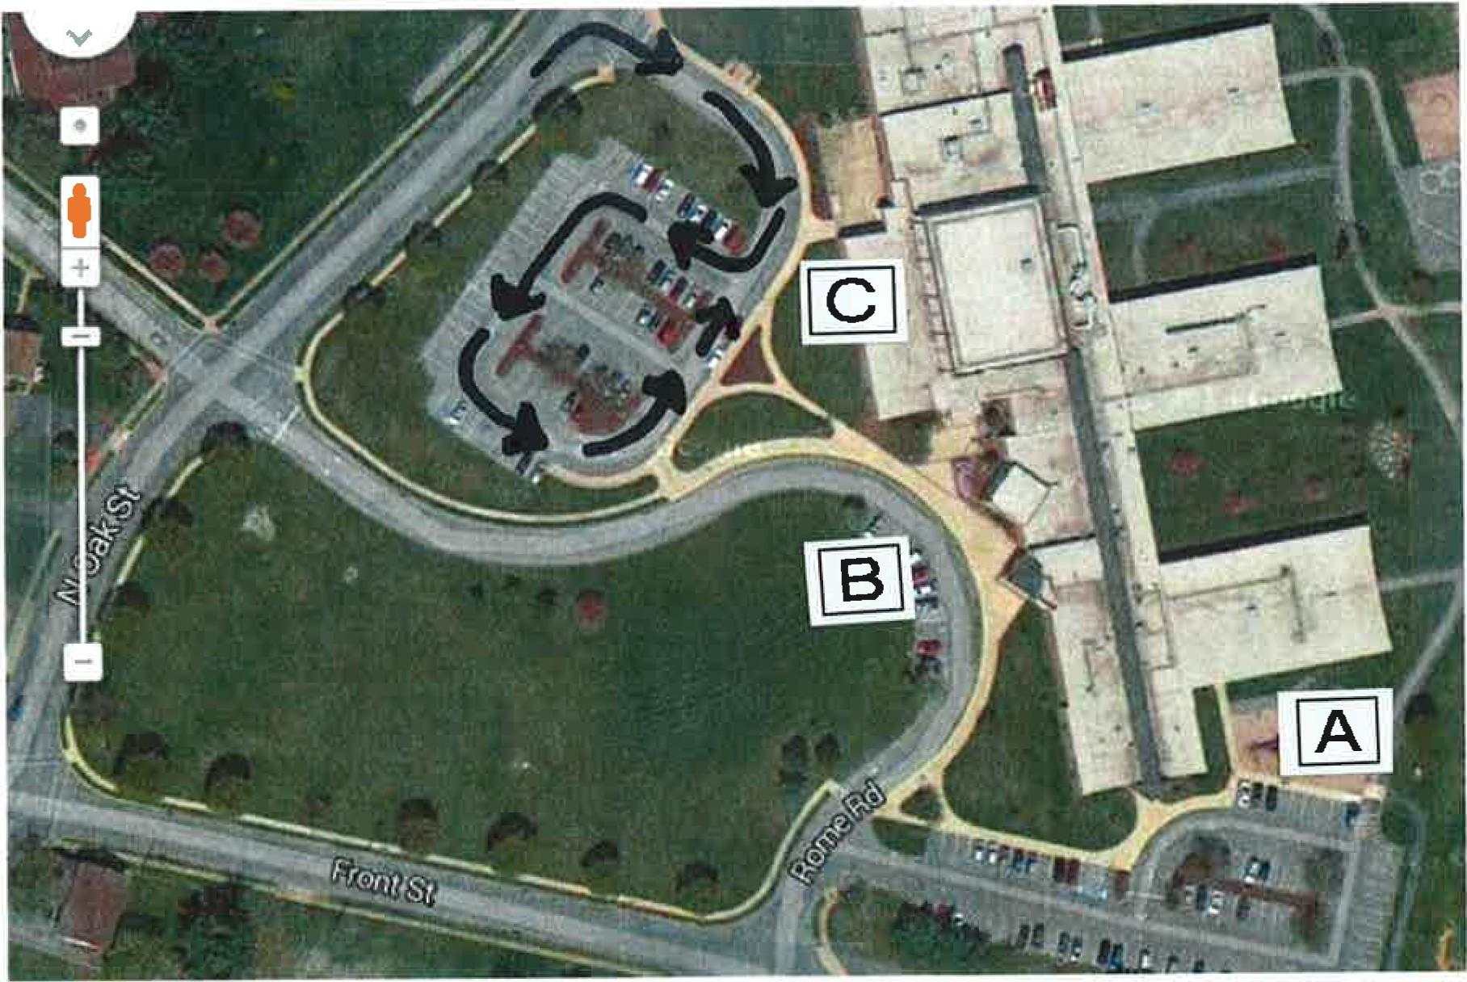

Parent Pick-up and Drop-Off Area:

- Area A is for Primary Students (Kindergarten – Second Grade) Pick-Up and Drop-Off
- Area C is for Intermediate Students (Grades 3 - 6) Pick-Up and Drop Off.
- Area B is ONLY for Buses and Vans from 7:45 am to 8:15 am and 2:15 pm - 2:45 pm

Arrival and Dismissal Times:

- Arrival 7:50 am- 8:00 am. Students arriving after 8 am will be considered late.
- Dismissal
  - 2:30 - Bus Students
  - 2:35 Walkers/Car Riders

PRIMARY Student Drop-Off

Students may be dropped off in Section A.
- You may either park and walk you r child to the door OR
- Pull up to the curb and drop your child off.

Safety Requirements
- Only one lane of traffic to drop students off. Please do NOT pull along side another car to drop off your student.
- Please exit the lot at a SAFE SPEED.

Primary Student Pick-Up

Please enter the parking lot on Section A of the map above. Park your car and meet your child at the side door. The sidewalk is designated as a No Parking Zone during student dismissal. In order to ensure student safety, we ask that no parent pull to the curb to pick-up your child.

Intermediate Student Drop-Off

Section C on the map is the Intermediate Student Drop-Off Zone. Please enter from N. Oak Street. Drivers are asked to follow the designated route indicated by arrows on the map.

Safety Requirements
- Only one lane of traffic to drop students off. Please do NOT pull along side another car to drop off your student.
- Please exit the lot at a SAFE SPEED Intermediate Student Pick-Up
Section C on the map is the Intermediate Student Pick-Up Zone. Please enter from N. Oak Street. Drivers are asked to follow the designated route indicated by arrows on the map.

Safety Requirements
- Please pull up as far as you are able in order to allow for as many cars as possible on the curbside.
- Please wait your turn - no double parking is allowed in order to ensure student safety.
- Please exit the lot at a SAFE SPEED.

Kindergarten Mid-Day Pick-Up (10:50 am) Section B on the map is for Kindergarten Pick-Up.

If you want to pick up your child at the front curb:
- Please enter from N. Oak Street. Drivers are asked to pull u p as far as possible (to the Stop Sign if you are the first parent here).
- Please stay in your car. Students will be sent to your car.
- Please wait your turn - no double parking is allowed in order to ensure student safety.
- Please exit the lot at a SAFE SPEED.

Everyone's goal is SAFETY FIRST. We thank you for your cooperation and support of these guidelines.

